ITM University Gwalior
School of Computing and Intelligent Systems
Project-Based Learning (PBL)
Mini Project Report — Submission Format
Course: Data Analytics Using Python
Course Code: CSL0312
Program: B.Tech. CSE (Artificial Intelligence & Machine Learning)
Semester: III Section: F
Academic Session: July–Dec 2026
Project Details
Project Title: Stock Price Trend Analysis Using Historical Data (NVIDIA Corporation – NVDA)
Domain (as per Section 6): Financial & Economics Analysis
Team Leader Name & Roll No.: K Anvesh Reddy (BETN1AI25168)
Team Member Name & Roll No.: G Madhava Reddy (BETN1AI25161)
Team Member Name & Roll No.: K Karthik (BETN1AI25179)
Faculty Mentor: Dr. Sanjay Jain
Date of Submission: 19-10-2026

1. Introduction & Problem Statement
Stock prices change every day under the influence of market demand, company performance, economic news and investor sentiment. Because prices keep moving, it is difficult for investors to recognise the direction of the market by looking at raw historical figures alone, and investing without a proper trend analysis can lead to financial losses. Analysing historical data helps investors, financial analysts and students understand past market behaviour and make more informed, data-driven observations.
This project studies the historical share price of NVIDIA Corporation (NVDA) from 2 January 2020 to 30 July 2026 using Python. The problem addressed is: how can the direction, strength, momentum and volume support of a stock’s price trend be identified clearly from its historical data? To answer this, the raw data downloaded from Yahoo Finance was cleaned and validated, explored statistically and then analysed with widely used technical indicators — the 20-day and 50-day Exponential Moving Averages (EMA), the Moving Average Convergence Divergence (MACD), the Average Directional Index (ADX) with its directional indicators (+DI and −DI), and trading volume.
The signals from these indicators were combined by a rule-based classifier that labels each trading day as Strong Bullish, Strong Bearish or Mixed/Weak. The results are presented through charts and tables so that price movements are easy to interpret. The scope of the project is limited to descriptive trend analysis of a single stock using Open, High, Low, Close and Volume data; it does not forecast future prices and the findings are not investment advice, since technical indicators are signals rather than guaranteed predictions.

2. Dataset Description & Source
Dataset Name: NVIDIA Corporation (NVDA) Historical Price Data (NVDA_Historical_Data.csv)
Source / Organization: Yahoo Finance
Dataset Link (URL): https://finance.yahoo.com/quote/NVDA/history/
Type of Dataset: ☒ Public ☐ Private ☐ Self-Collected
Number of Records: 1,652 trading days (2020-01-02 to 2026-07-30)
Number of Attributes/Columns: 6 (Date, Close, High, Low, Open, Volume)
☒ Dataset meets minimum quality criteria (Section 7): 1,652 records (minimum 500), 6 attributes (minimum 5) and zero missing values after removing the two header rows of the Yahoo Finance file.
Brief description of attributes/columns
Column | Final Data Type | Description
Date | datetime64[ns] | Trading date; the dataset is sorted from oldest to newest.
Open | float64 | Price of the first trade of the day (USD).
High | float64 | Highest traded price during the day (USD).
Low | float64 | Lowest traded price during the day (USD).
Close | float64 | Closing price of the day (USD), as provided by Yahoo Finance (prices appear split-adjusted).
Volume | float64 | Number of shares traded during the day.

3. Data Cleaning & Preprocessing
The raw CSV exported from Yahoo Finance contains two extra header rows (“Ticker” and “Date”) below the column names, which made every column load as text. The following steps were carried out in Google Colab and verified at each stage.
S. No. | Step | Action and Result
1 | Load data | NumPy, pandas, Matplotlib and Seaborn were imported and the CSV was read into a DataFrame named stock.
2 | Remove extra header rows | The “Ticker” and “Date” rows (index 0 and 1) were dropped and the index was reset, leaving 1,652 records.
3 | Rename column | The first column, named “Price” by Yahoo Finance, was renamed “Date”.
4 | Fix data types | All six columns were initially of type object. Date was converted to datetime64[ns] and Close, High, Low, Open and Volume were converted to float64.
5 | Missing values | Null-value check returned 0 for every column; no imputation was required.
6 | Duplicates | The duplicate-row check returned 0; no rows were removed.
7 | Invalid prices | Minimum values were High 5.22, Low 4.49, Open 4.98 and Close 4.89 — all positive, so no zero or negative prices exist.
8 | Chronological order | The Date column is monotonically increasing (True), so the data is correctly arranged from oldest to newest for trend analysis.
9 | Price consistency | No record has an Open or a Close above the High or below the Low (0 violations in both checks).

After these steps the dataset was complete, correctly typed, sorted and free of logical errors, so it was suitable for indicator calculation. The complete code and printed outputs for every step are given in Appendix A. Outlier removal was deliberately not applied: extreme daily moves in a stock are genuine market events and are part of the behaviour being studied.

4. Exploratory Data Analysis (EDA)
4.1 Summary statistics
Descriptive statistics were generated for Open, High, Low, Close and Volume. Prices span a very wide range because NVDA rose from under 5 USD to over 235 USD within the study period.
Statistic | Open | High | Low | Close | Volume (millions)
Count | 1652 | 1652 | 1652 | 1652 | 1652
Mean | 69.56 | 70.70 | 68.30 | 69.54 | 387.91
Std. Deviation | 66.85 | 67.79 | 65.74 | 66.78 | 198.87
Minimum | 4.98 | 5.22 | 4.49 | 4.89 | 65.53
25% | 15.32 | 15.63 | 15.07 | 15.32 | 224.17
50% (Median) | 30.12 | 30.56 | 29.41 | 30.06 | 365.27
75% | 126.38 | 128.87 | 123.33 | 126.28 | 504.40
Maximum | 229.60 | 236.26 | 229.03 | 235.47 | 1,543.91

4.2 Daily return and technical indicators
- Daily return: calculated as the percentage change of the closing price from the previous day (the first row is NaN because there is no earlier day).
- EMA 20 and EMA 50: exponential moving averages of the closing price. When EMA 20 is above EMA 50 the trend is labelled Bullish, otherwise Bearish. A crossover is recorded on the day the label changes from the previous day.
- MACD (12, 26, 9): MACD line = EMA 12 − EMA 26; the signal line is a 9-period EMA of the MACD line; the histogram is MACD minus signal. A histogram moving from negative to positive is a bullish crossover and from positive to negative a bearish crossover.
- ADX (14) with +DI and −DI: calculated with the ta library to measure trend strength irrespective of direction. Below 20 is typically a weak or sideways trend, 20–25 a developing trend and above 25 a stronger trend.
- Volume analysis: a day is flagged as high-volume when its volume exceeds twice the average volume.
4.3 Crossover signals identified
Indicator | Bullish Crossovers | Bearish Crossovers | No Crossover Days
EMA 20 / EMA 50 | 18 | 18 | 1,616
MACD / Signal line | 66 | 66 | 1,520

The first EMA crossover was bullish on 2020-01-10 and the first bearish crossover was on 2020-03-16, when the Close fell to its period low of 4.89. The most recent EMA crossovers are bullish on 2026-07-15 and bearish on 2026-07-28. Several clusters of crossovers on consecutive or nearby days (for example 2020-12-31 to 2021-01-11 and 2023-01-06 to 2023-01-09) show that EMA crossovers can flip quickly when the two averages are close together.
4.4 Volume analysis
The average daily volume is 387,911,210 shares. The highest volume in the dataset is 1,543,911,000 shares on 2023-05-25, when the Close was 37.90 and the daily return was +24.37%; on that day ADX was 38.01 with +DI at 61.02 against −DI at 9.50, showing very strong buying pressure. The last ten high-volume days (above twice the average) fall between 2023-08-24 and 2025-01-27, and the highest of these include 1,156,044,000 shares on 2023-08-24 and 1,142,269,000 shares on 2024-03-08.
4.5 Overall trend classification
A Strong Bullish day requires EMA 20 > EMA 50, MACD > signal line, ADX > 25 and +DI > −DI. A Strong Bearish day requires EMA 20 < EMA 50, MACD < signal line, ADX > 25 and −DI > +DI. All other days are Mixed/Weak.
Overall Trend | Number of Days | Share of 1,652 Days | Interpretation
Mixed/Weak | 1,299 | 78.6% | No strong, confirmed trend
Strong Bullish | 282 | 17.1% | Confirmed uptrend
Strong Bearish | 71 | 4.3% | Confirmed downtrend

5. Data Visualization & Observations
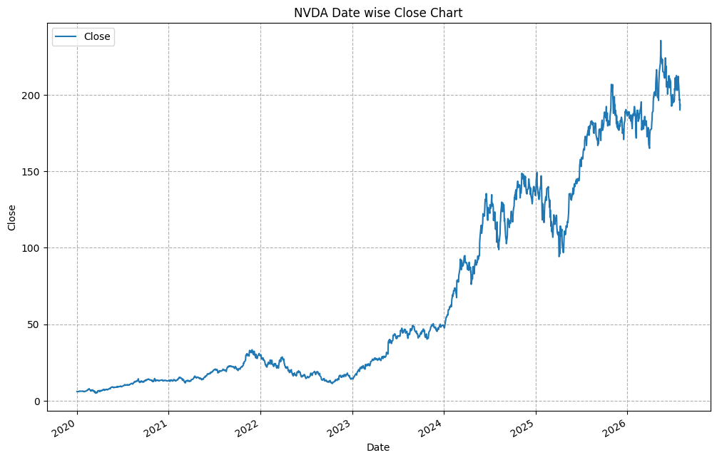
Figure 1: NVDA date-wise closing price chart (2020–2026)
Observation: The price stayed below about 35 USD until 2023 and then rose steeply from early 2024, reaching a peak of roughly 235 USD in mid-2026. The long-term direction is clearly upward, with sharp corrections in 2022 and in early 2025.
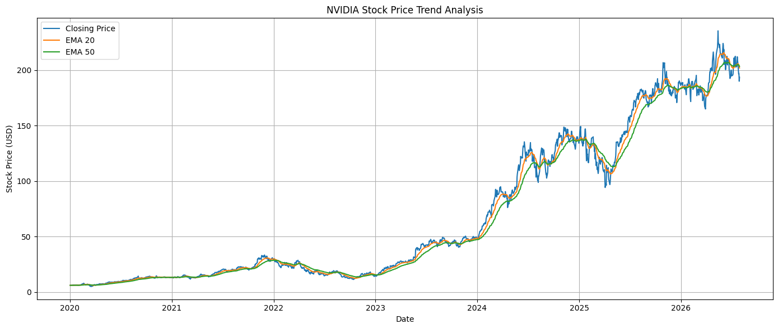
Figure 2: NVDA closing price with EMA 20 and EMA 50
Observation: Both EMAs follow the price closely and smooth out its daily noise. EMA 20 reacts faster than EMA 50. During strong rallies (2023–2024 and 2025) EMA 20 stays above EMA 50, while in the 2022 decline and the early-2025 dip it falls below it. The two lines are almost on top of each other at the end of the series, showing a trend that has recently lost direction.
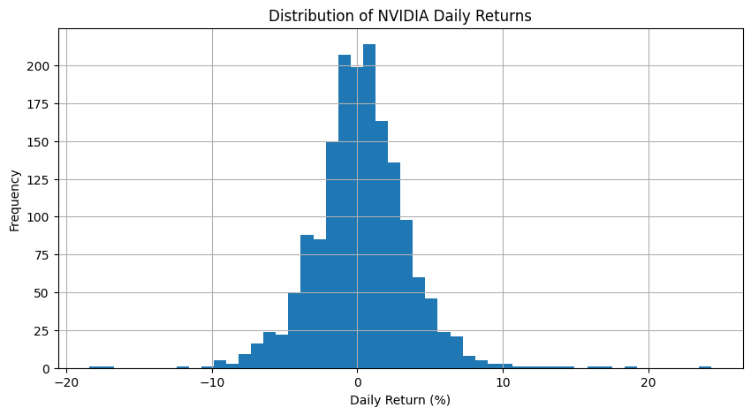
Figure 3: Distribution of NVDA daily returns
Observation: Daily returns are centred near 0% and most values lie between about −5% and +5%, giving an almost bell-shaped histogram. A few extreme days exist on both tails, up to about +24% and close to −18%, showing that large single-day moves do occur.
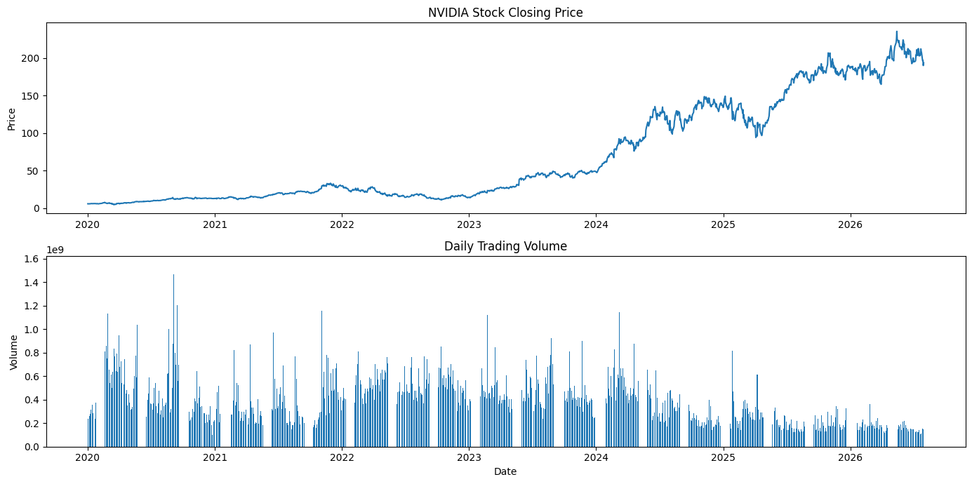
Figure 4: NVDA closing price and daily trading volume
Observation: Volume was highest in 2020–2021, remained high through 2023–early 2024 with several spikes above 1 billion shares, and then declined to a lower, steadier level from 2025 even while the price kept making new highs.
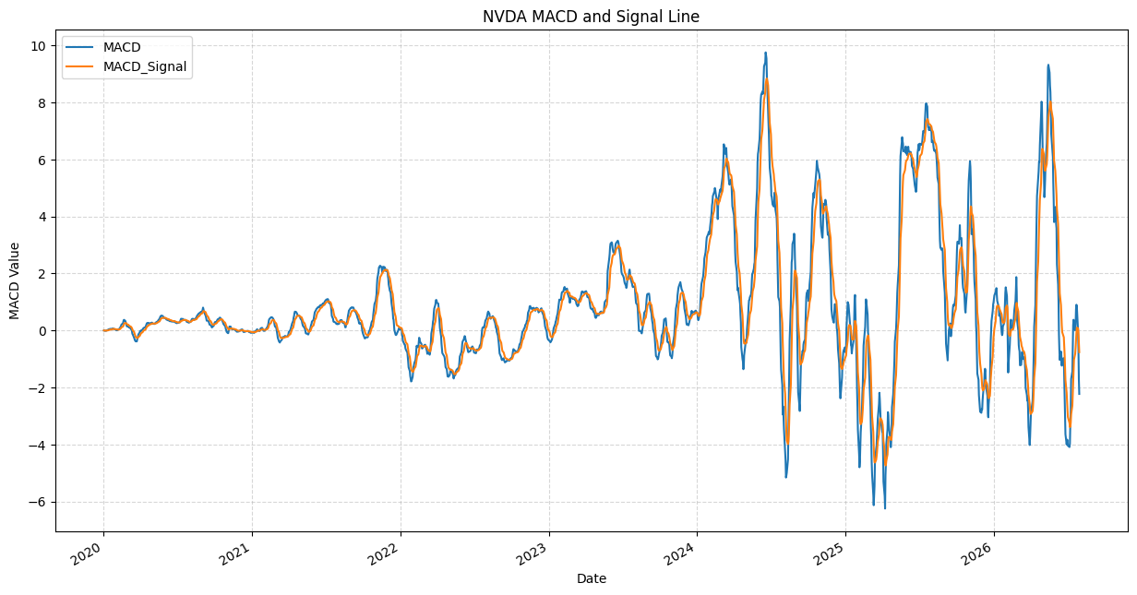
Figure 5: NVDA MACD and signal line
Observation: The MACD and signal lines oscillate around zero. Their swings were small before 2023 and became much larger from 2024 onwards (peaks near +10 and troughs near −6), indicating stronger momentum and higher volatility in the later period.
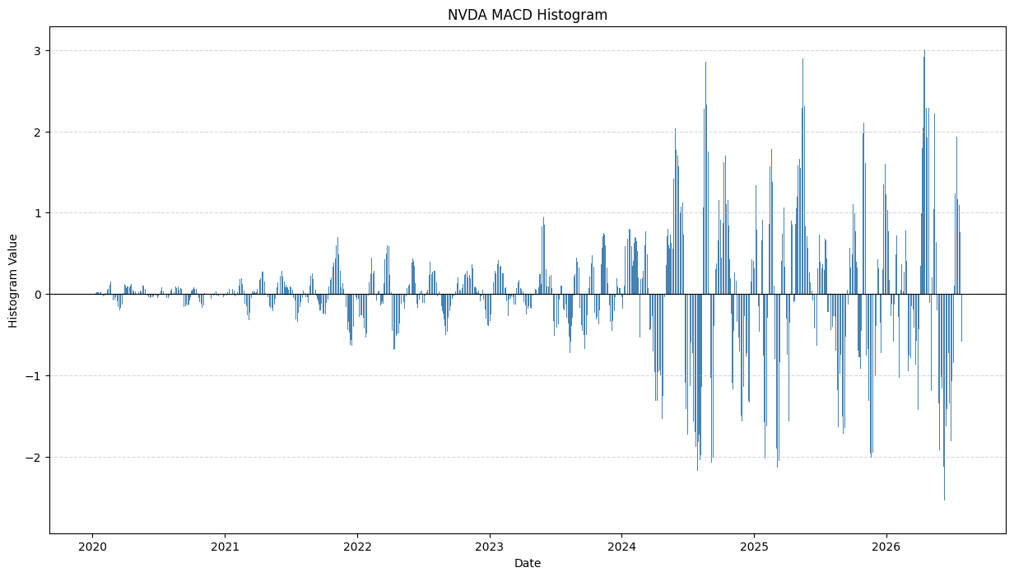
Figure 6: NVDA MACD histogram
Observation: Bars above zero show bullish momentum and bars below zero show bearish momentum. The histogram is very small before 2023 and has large positive and negative spikes after 2024 (about +3 to −2.5). The most recent bars are negative, in line with the MACD signal in Section 4.
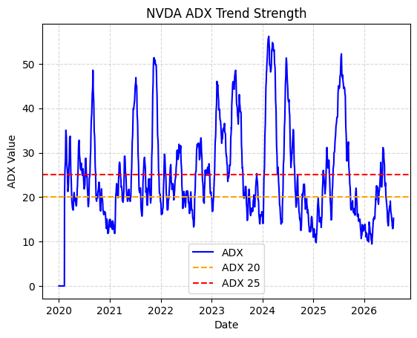
Figure 7: NVDA ADX trend strength with levels 20 and 25
Observation: ADX is above 25 only in short bursts — notably 2021, late 2021, 2023–2024 and 2025 with peaks of about 50–56 — and spends most of the time near or below 20. The latest values are about 15, so the market is currently in a weak or sideways phase. The flat line at zero at the start is the warm-up period of the indicator.
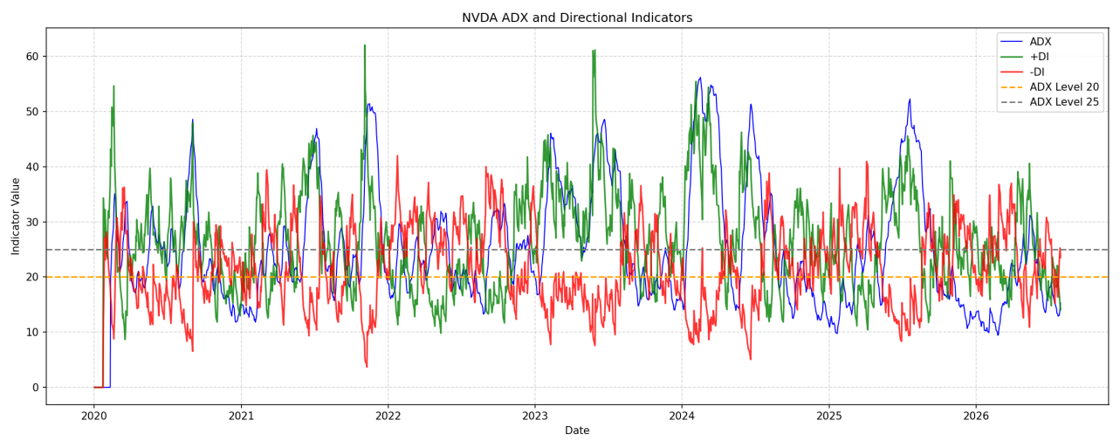
Figure 8: NVDA ADX with +DI and −DI directional indicators
Observation: When +DI (green) is above −DI (red) buyers dominate the direction, and when −DI is above +DI sellers dominate. The directional lines cross often, while ADX (blue) shows whether the move has real strength: the clearest bullish phases occur when +DI is well above −DI and ADX rises above 25. At the end of the series −DI (about 23.5) is above +DI (about 14.0) but ADX is only about 15, so the recent selling pressure is directional but not yet backed by a strong trend.
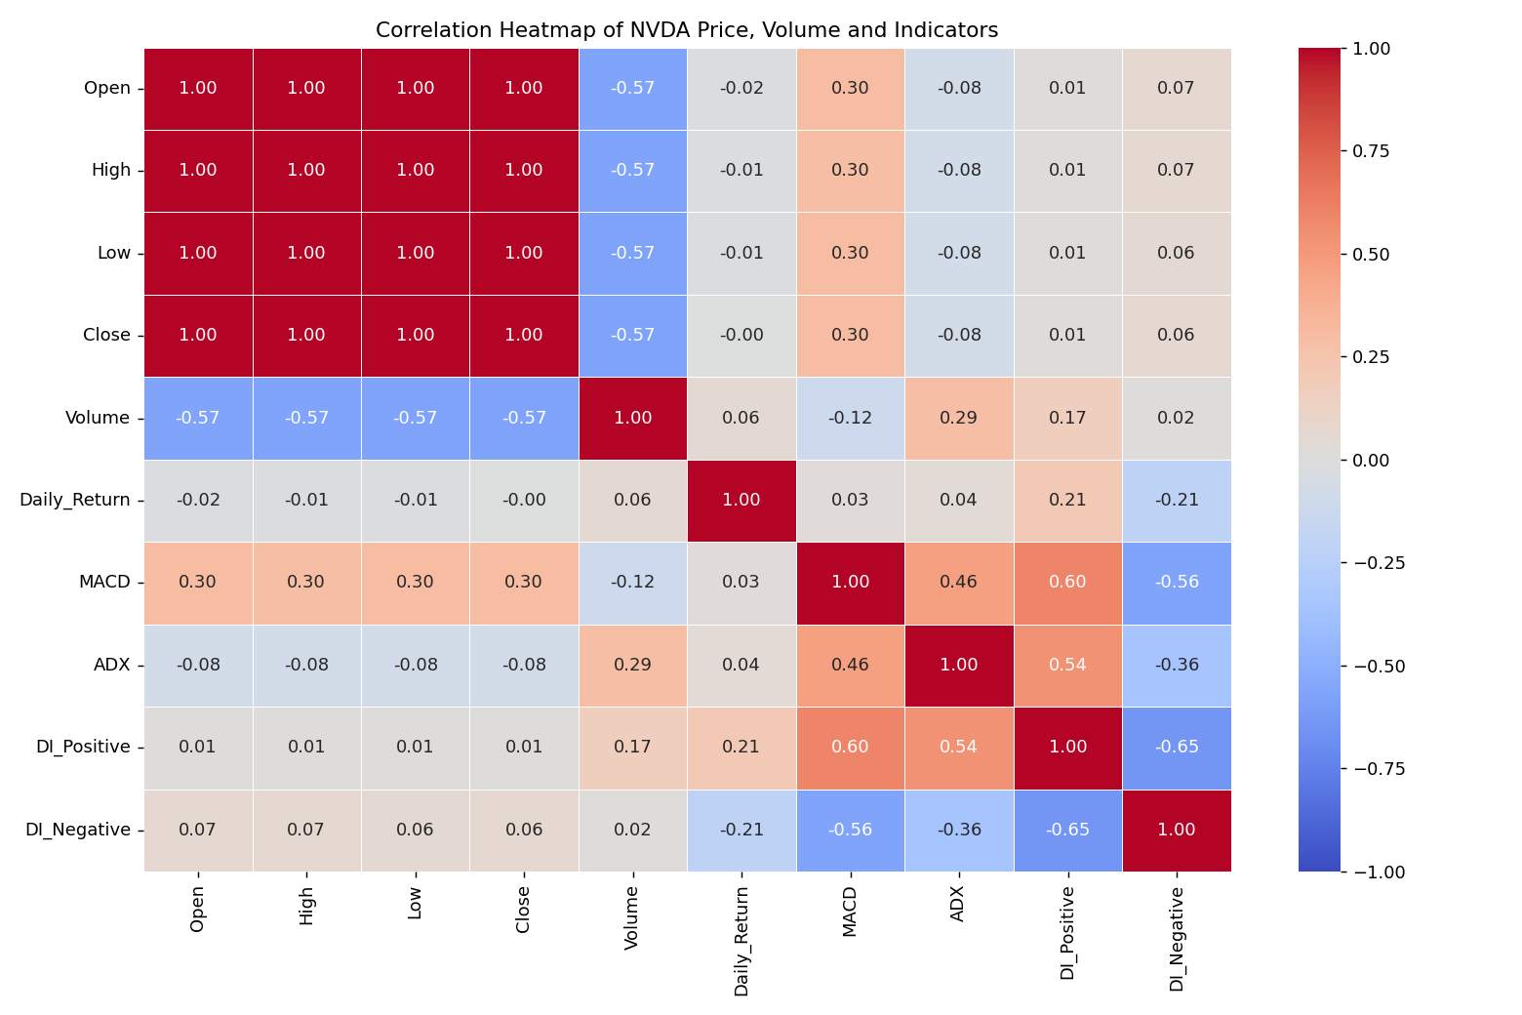
Figure 9: Correlation heatmap of NVDA price, volume and indicators
Observation: Red cells show positive and blue cells negative correlation. Open, High, Low and Close are almost perfectly correlated (1.00) because they move together within a day. Volume is moderately negatively correlated with price (−0.57), matching the earlier chart where volume fell while price rose. Daily return has almost no correlation with the price level, and the indicator columns show their strongest links with each other: MACD with +DI (0.60) and −DI (−0.56), and +DI with −DI (−0.65).

6. Statistical Analysis (Basic)
6.1 Central tendency and spread
- Closing price: mean = 69.54, median = 30.06 and standard deviation = 66.78. The mean is more than double the median, so the distribution is strongly right-skewed — most days occurred at lower price levels while the later high-price years pull the average up.
- Variability: the standard deviation (66.78) is almost equal to the mean (69.54), giving a coefficient of variation of about 0.96. This reflects the very large price growth over the period rather than only day-to-day noise.
- Price range: Close ranged from 4.89 to 235.47; the inter-quartile range is 15.32 (25%) to 126.28 (75%).
- Volume: mean 387.91 million and median 365.27 million shares (slightly right-skewed); standard deviation 198.87 million; range 65.53 million to 1,543.91 million.
- Daily returns: the histogram is symmetric around zero with fat tails; the largest observed daily gain is +24.37% (2023-05-25).
6.2 Frequency of signals
- EMA crossovers: 36 in total (18 bullish + 18 bearish) over 1,652 days, about one crossover every 46 trading days.
- MACD crossovers: 132 in total (66 bullish + 66 bearish), about one every 12.5 trading days — nearly four times as frequent as EMA crossovers.
- Overall trend: Mixed/Weak 78.6%, Strong Bullish 17.1%, Strong Bearish 4.3% of all days; strong bullish days outnumber strong bearish days by about 4 to 1 (282 : 71).
- High-volume days are defined by the threshold 2 × 387.91 million = 775.82 million shares.
6.3 Latest indicator snapshot (30 July 2026)
Indicator | Value | Reading
Close | 193.54 | Below both EMAs
EMA 20 / EMA 50 | 201.97 / 203.44 | EMA 20 < EMA 50: Bearish trend
MACD / Signal | −2.226 / −0.761 | MACD below signal line
MACD histogram | −1.465 | Negative and widening over the last four days
ADX | 15.25 | Below 20: weak or sideways trend
+DI / −DI | 14.05 / 23.52 | −DI above +DI: sellers dominate direction

Because ADX (15.25) is below 25, the classification rule would label the latest day as Mixed/Weak even though the directional indicators lean bearish. ADX guidelines are rules of thumb and not guaranteed trading signals.
6.4 Correlation analysis
Pearson correlation coefficients were calculated for Open, High, Low, Close, Volume, Daily Return, MACD, ADX, +DI and −DI and displayed as a heatmap (Figure 9). The main results are summarised below.
Variable pair | Correlation | Interpretation
Open / High / Low / Close | 1.00 | Prices move together within a day, so these columns carry almost the same information
Close and Volume | −0.57 | Moderate negative: volume was higher when prices were lower (earlier years)
Close and Daily Return | −0.00 | No relationship between the price level and the size of daily moves
Close and MACD | 0.30 | Weak positive relationship
MACD and +DI | 0.60 | Momentum rises together with positive directional movement
MACD and −DI | −0.56 | Momentum falls when negative directional movement rises
+DI and −DI | −0.65 | The two directional indicators tend to move in opposite directions
ADX and Volume | 0.29 | Weak positive: stronger trends tend to occur with higher volume

Correlation measures how two variables move together and does not prove that one causes the other. The very high correlation between Open, High, Low and Close is expected for price data and should not be treated as an independent finding.

7. Key Insights & Interpretation
1. Strong long-term uptrend: the closing price rose from 5.96 USD on 2 January 2020 to 193.54 USD on 30 July 2026 (about 32 times), after peaking at 235.47 USD. The growth accelerated from 2024 and was interrupted by corrections in 2022 and early 2025.
2. Confirmed trends are uncommon: 78.6% of days are Mixed/Weak, meaning that all four conditions (EMA, MACD, ADX and DI) agree on only about one day in five. Requiring several indicators to agree filters out noise but also reduces the number of signals.
3. Bullish confirmation dominates: Strong Bullish days (282) are about four times as many as Strong Bearish days (71), consistent with NVDA’s overall upward path during the period.
4. Indicators differ in speed: MACD produced 66 crossovers of each type against 18 for EMA 20/50, so MACD is more sensitive but gives more frequent, possibly false, signals while EMA crossovers are slower and rarer. Since moving averages lag price, a crossover can occur after a move has already begun.
5. Current position is a weak pullback: short-term indicators are bearish (EMA 20 below EMA 50 since 28 July 2026, negative and widening MACD histogram, −DI above +DI), but ADX of 15.25 shows the downward trend is not yet strong. This suggests a pullback or consolidation rather than a confirmed downtrend.
6. Volume reveals participation: the largest volume (1.54 billion shares on 2023-05-25) coincided with the biggest daily gain (+24.37%) and a very strong ADX of 38.01, supporting the idea that big moves are backed by heavy participation. Volume has been lower since 2025, even as prices reached new highs; this was observed in the data but its cause was not analysed.
7. Correlation view: price and volume are moderately negatively correlated (−0.57), while MACD, +DI and −DI are strongly related to each other (0.60 and −0.56 for MACD; −0.65 between +DI and −DI). This shows that the momentum and directional indicators largely confirm one another, but daily returns are almost unrelated to the price level (−0.00).

8. Conclusion & Future Scope
This project successfully applied Python-based data cleaning, exploratory analysis, technical indicators and visualization to six and a half years of NVIDIA stock data. The Yahoo Finance data was cleaned and validated (1,652 records, no missing values, no duplicates, no invalid prices) and then analysed using EMA 20/50, MACD, ADX with +DI/−DI and volume. The analysis shows that NVDA has been in a pronounced long-term uptrend, that confirmed strong trends are relatively rare (about 21% of days, mostly bullish), and that as of 30 July 2026 the short-term indicators are bearish while trend strength is weak. The rule-based classification makes the trend easy to read, but it describes the past and should be treated as decision support rather than a prediction or investment advice.
Future scope
- Add the remaining techniques listed in the synopsis — Price Action (swing highs/lows) and On-Balance Volume (OBV) — to further confirm trends.
- Back-test the EMA and MACD crossover signals to measure how often they led to profitable moves, and tune the indicator periods.
- Build interactive dashboards using Plotly so users can explore periods and indicators.
- Extend the analysis to several stocks or sector indices for comparison, and add volatility measures.
- Use machine-learning models such as time-series forecasting or classification on the indicator features to predict trend direction.

9. References
1. Yahoo Finance — NVIDIA Corporation (NVDA) historical prices (dataset source). https://finance.yahoo.com/quote/NVDA/history/
2. NumPy — numerical and statistical computing library for Python. https://numpy.org/
3. pandas — data cleaning and analysis library for Python. https://pandas.pydata.org/
4. Matplotlib — plotting library used to create the charts. https://matplotlib.org/
5. Seaborn — statistical data visualization library. https://seaborn.pydata.org/
6. ta (Technical Analysis Library in Python) — used to calculate ADX, +DI and −DI. https://github.com/bukosabino/ta
7. Google Colab — development environment used to run the notebook. https://colab.research.google.com/
8. Wilder, J. W. (1978). New Concepts in Technical Trading Systems. Trend Research — original definition of the ADX and directional indicators.

10. AI Tool Usage Declaration
AI Tool Used | Purpose (e.g., debugging, documentation) | Extent of Use / Section Applied
Claude (Anthropic) | Report Documentation | Report text, Sections 1–10; no new analysis or charts were created
ChatGPT | code assistance, debugging | Assisted with Python code development, data analysis explanations

11. Project Links & Deliverables
GitHub Repository Link: https://github.com/kanveshreddy/stock_trend
Python Notebook (.ipynb) File Name: Untitled8_ordered.ipynb
PBL Report File Name: PBL_Report_NVDA_Stock_Trend_Analysis.docx
☐ GitHub repository includes code, notebook, and a PBL report and README

12. Report Structure Checklist (Section 8 Compliance)
S. No. | Report Section (as per Section 8 format) | Included (✓)
1 | Title Page | ✓
2 | Introduction & Problem Statement | ✓
3 | Dataset Description & Source | ✓
4 | Data Cleaning & Preprocessing | ✓
5 | Exploratory Data Analysis (EDA) | ✓
6 | Data Visualization & Observations | ✓
7 | Statistical Analysis (Basic) | ✓
8 | Key Insights & Interpretation | ✓
9 | Conclusion & Future Scope | ✓
10 | References | ✓

13. Declaration by Student(s)
I/We hereby declare that this Mini Project Report is our own original work, prepared using publicly available/open datasets. All sources of data, references, and AI tool assistance have been duly acknowledged. I/We understand that any instance of plagiarism in code or report will attract strict academic action, as per Section 15 of the PBL guidelines.
Team Leader Signature: _________________________________________
Team Member Signature(s): _________________________________________
Date: 21-10-2026

14. For Faculty Use Only — PBL Final Report Evaluation
Evaluation Component B — PBL Final Report Submission | Mid-Term (PBL Based): 10 Marks (Section 10 of PBL Guidelines)
Evaluation Criteria | Max Marks | Marks Awarded
Data Cleaning & Preprocessing | 2
Exploratory Data Analysis (EDA) | 2
Visualization & Observations | 2
Statistical Analysis | 2
Insights, Interpretation & Conclusion | 2
Total (out of 10) | 10
Faculty Remarks:
Faculty Mentor Signature: _________________________________________
Date: 21-10-2026

